Assignment 4

1. 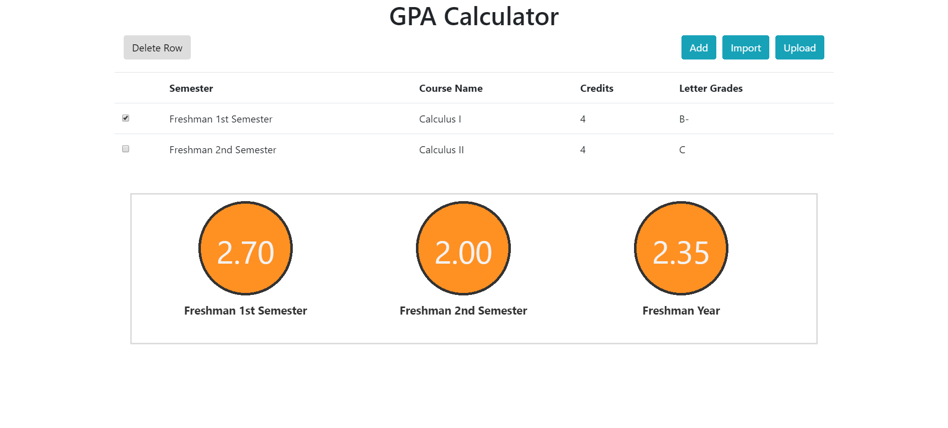Adding delete function: Select the row you want to delete, and click the “delete row” button to delete them.
2. 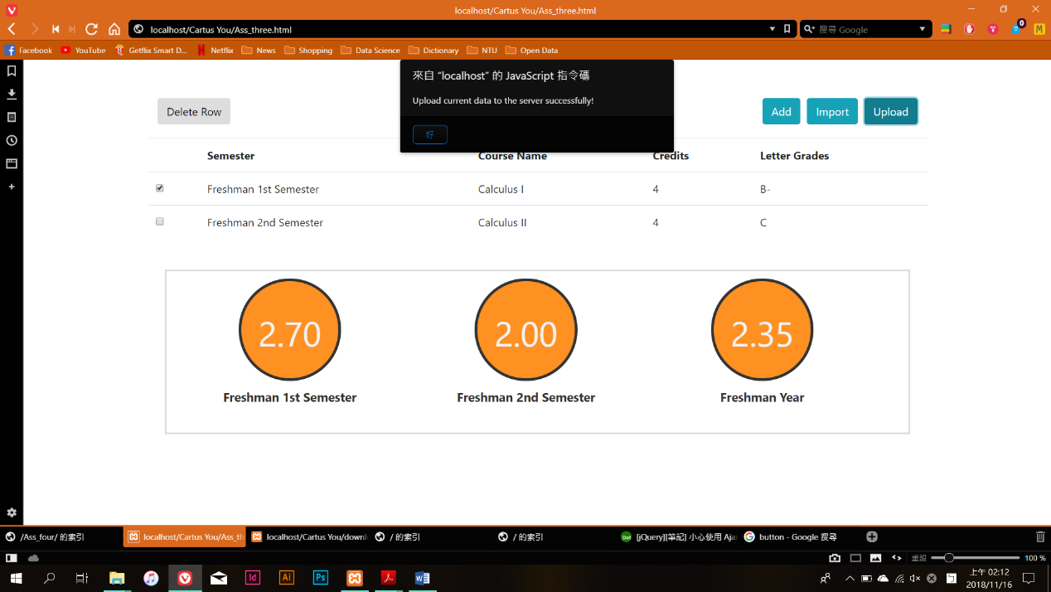Adding upload function: Click “upload” button, and then the recent data would be save as json file. Note that if there exist an previous data, once you upload again, the data will be replaced by the new one.
3. 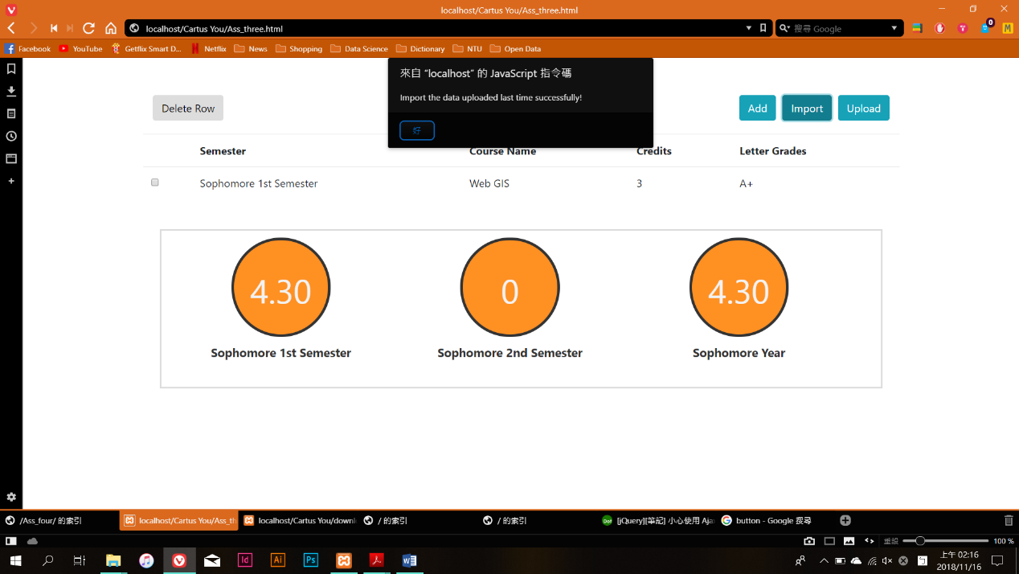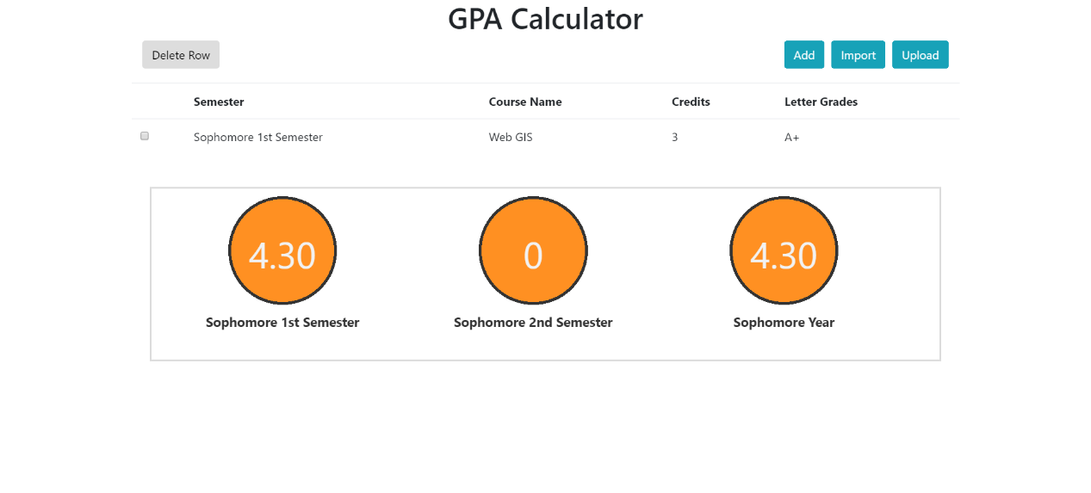Adding import function: Click “Import” button to get the data you uploaded last time.

